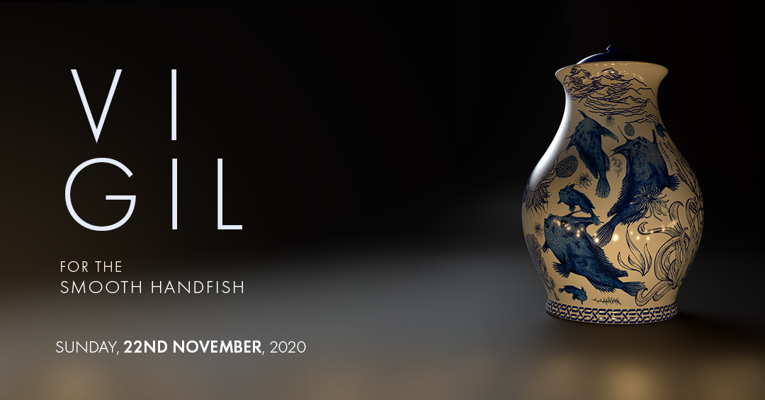

IMAGE DESCRIPTION: The words "Vigil for the Smooth Handfish " and the event date, “Sunday, 22nd November 2020” are to the left of the screen in white text overlaid across a blurred background. To the right sits a ceramic urn decorated with navy painted images of the Smooth Handfish in various swimming poses. Marine plants and seaweed decorate the spaces in between. Reflections of candles and their lighting can be seen around the circumference of the Urn.

The Parallel Effect’s Vigil for the Smooth Handfish
ACCESS GUIDE

The Parallel Effect is a values-driven collective that endeavours to embed access into the design and ethos of all work produced.

Vigil for the Smooth Handfish is a free event that takes place in digital environments in recorded formats.

The event will first be broadcast online on Sunday November 22 from 3pm. This broadcast can be accessed via the project website at www.handfishvigil.com

The following methods will be used to make content accessible:
- Open captioning
- Text transcripts
- Audio description
The live broadcast event of Vigil for the Smooth Handfish on Sunday November 22 will be captioned. Text transcripts will also be made available upon request.

Following the live broadcast, each of the individual contributions encompassing the Vigil for the Smooth Handfish will be made available online at the project website from November 29 and the full broadcast will also be made available upon request.

In content where there is little to no audio available, these contributions will be audio described.

Once this content is identified, the audio described content will be itemised on the project website and inside this access guide and made available upon request and will be accessible via the website from November 29.
Please email us to discuss your specific access needs: ineedtheparalleleffect@gmail.com

